**Black Box Testing** is a software testing method in which the functionalities of software applications are tested without having knowledge of internal code structure, implementation details and internal paths. Black Box Testing mainly focuses on input and output of software applications and it is entirely based on software requirements and specifications. It is also known as Behavioral Testing.

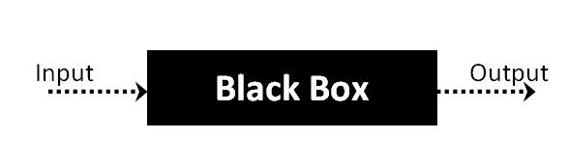

## Black Box Testing Techniques

Following are the prominent[Test Strategy](https://www.guru99.com/how-to-create-test-strategy-document.html)amongst the many used in Black box Testing

* **Equivalence Class Testing:** It is used to minimize the number of possible test cases to an optimum level while maintains reasonable test coverage.
* **Boundary Value Testing:** Boundary value testing is focused on the values at boundaries. This technique determines whether a certain range of values are acceptable by the system or not. It is very useful in reducing the number of test cases. It is most suitable for the systems where an input is within certain ranges.